
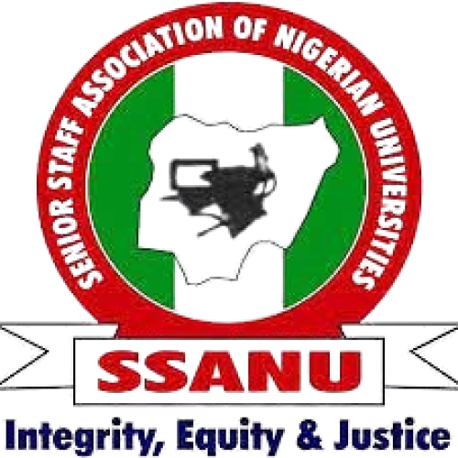
STATE OF THE NATION ADDRESS
BY THE NATIONAL PRESIDENT OF SSANU
COMRADE MOHAMMED HARUNA IBRAHIM _{fnipr, fnils, fciml, manupa}
AT THE 56TH NATIONAL EXECUTIVE COUNCIL (NEC) MEETING HELD AT UNIVERSITY OF UYO, AKWA IBOM STATE FROM
30TH SEPTEMBER – 1ST OCTOBER, 2026

Comrades, distinguished members of the National Executive Council, ladies and gentlemen,
I welcome you warmly to another meeting of the National Executive Council of our great Union.
As we gather once again as leaders of our great Union, we have a responsibility not only to examine matters affecting our members, but also to reflect on developments shaping the lives and wellbeing of the Nigerian people.
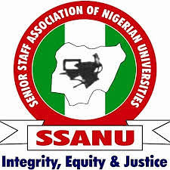
Our nation has witnessed further developments in security, the economy, education, agriculture, technology, energy and governance. These developments make it necessary for us, once again, to reflect on the state of our nation and to speak clearly on matters that affect the welfare of our members and the larger Nigerian society.
SSANU has always believed that the condition of the Nigerian worker cannot be separated from the condition of Nigeria itself.

SECURITY OF LIVES AND PROPERTY
The security of lives and property remains a fundamental responsibility of government. The continued cases of kidnapping, banditry and other violent crimes, including the recent mass abduction in Niger State, remain deeply concerning and continue to affect agriculture, education, productivity and the general wellbeing of Nigerians.
We therefore call on government and the security agencies to strengthen intelligence gathering, community engagement and the protection of vulnerable communities and public institutions. Universities must also improve campus security through effective surveillance, access control and emergency response systems, as every Nigerian deserves to live, work, study and travel in safety.

THE ECONOMY AND THE COST OF LIVING
We acknowledge the growth recorded in the Nigerian economy. However, economic growth must translate into real improvements in the lives of the people. For the average worker, the true measure of progress is whether income can meet basic needs, particularly as food, transportation, energy, housing, healthcare and education costs remain high.
The major concern for workers is therefore purchasing power. We urge government to pursue policies that ease the burden on families, protect incomes and ensure that improvements in economic indicators are reflected in better living standards. Economic growth must ultimately be felt in the homes of ordinary Nigerians.

THE UNIVERSITY SYSTEM AND IMPLEMENTATION OF AGREEMENTS
The signing of the 2026 FGN/SSANU Agreement was a major milestone for our Union, reflecting years of engagement and negotiation. We therefore call for the full, faithful and consistent implementation of all provisions of the Agreement, as the credibility of collective bargaining depends on respect for agreements freely entered into.
We acknowledge areas where progress has been made, while calling for timely resolution of all outstanding issues through sincere dialogue. At the same time, our universities must be adequately funded to provide reliable power, functional laboratories, libraries, ICT infrastructure, security and proper maintenance. Nigeria cannot build a strong and competitive economy without strong and properly funded universities.

KING'S COLLEGE AND THE FUTURE OF PUBLIC EDUCATION
SSANU unequivocally rejects any arrangement that seeks to concession, privatise or transfer the management of King’s College, Lagos, or any other public educational institution, to an alumni association or any private body. While we recognise and appreciate the valuable contributions of Old Boys’ Associations and other stakeholders to the development of public schools, such support must not translate into the takeover of management responsibilities that constitutionally and fundamentally belong to government.
The proposed arrangement raises serious concerns about the future of public education, including questions of ownership, affordability, accessibility, accountability, job security and the rights of workers. Public institutions must not be gradually transferred into private hands under the guise of management reform, partnership or improved efficiency. Such a precedent could open the door to the commercialisation and eventual privatisation of public education, with far-reaching consequences for ordinary Nigerians.
SSANU therefore calls on the Federal Government to halt the proposed arrangement and subject any contemplated reform of King’s College to broad and transparent consultation with workers, parents, students, alumni and other critical stakeholders. Any reform must preserve the public ownership, character and accessibility of the institution, protect the rights and conditions of service of its workers, and ensure that government does not abdicate its responsibility to adequately fund and manage public education.
Our position is clear: King’s College must remain a fully public institution, publicly owned, publicly managed and accessible to Nigerians irrespective of their economic status. SSANU will resist any policy or arrangement capable of undermining these principles or setting a precedent for the gradual privatisation of Nigeria’s public educational institutions.

AGRICULTURE AND FOOD SECURITY
Food security remains a major national concern, as many Nigerians continue to struggle with access to sufficient and affordable food. Insecurity, high transportation costs, expensive farm inputs, flooding and displacement have all affected agricultural production and contributed to rising food prices.
Government must strengthen the security of farming communities, support farmers and improve agricultural infrastructure. Our universities also have a vital role to play through research, innovation, biotechnology and modern farming methods. Nigeria must better connect university research with practical solutions that improve food production and strengthen national food security.
A nation with Nigeria’s agricultural potential must not accept hunger as an inevitable condition of its people

TECHNOLOGY, CYBERSECURITY AND THE FUTURE OF WORK
The future of work must include the worker.
Artificial intelligence, automation, cloud computing and other digital technologies are rapidly transforming the workplace. Nigeria must embrace these opportunities while ensuring that workers are equipped through continuous training and retraining to remain relevant in the changing world of work.
Our universities must also strengthen investment in digital skills, artificial intelligence, modern ICT infrastructure and cybersecurity to protect sensitive institutional data and improve service delivery. Technology must enhance productivity and create opportunities without leaving workers behind.

ENERGY AND INFRASTRUCTURE
The cost and reliability of energy remain major challenges for households, businesses and public institutions. Universities require stable electricity to power laboratories, libraries, ICT facilities, medical services and other essential operations, while rising petrol and diesel prices continue to increase the cost of alternative power.
Government must therefore improve electricity supply and expand access to affordable renewable energy solutions. Public institutions, particularly universities, should be supported to adopt sustainable energy systems that reduce costs and improve service delivery.

NATIONAL UNITY AND RESPONSIBLE LEADERSHIP
Nigeria requires unity, responsible leadership and a renewed commitment to the common good. Our differences must not overshadow our shared responsibility to address insecurity, unemployment, poverty, education, healthcare, infrastructure and the welfare of citizens.
Leadership at all levels must place the public interest above personal or political considerations. Organized labour must also remain a responsible voice in national development, speaking not only for the welfare of workers but also for stronger institutions, good governance and a more peaceful and prosperous Nigeria.

RULE OF LAW AND ACCOUNTABILITY
Recent reports of deaths involving persons in the custody of security agencies have raised serious public concern and must be thoroughly investigated. At the same time, unlawful activities such as illegal mining and other forms of criminality must be firmly addressed.
Law enforcement must always operate within the law and with respect for the rights and dignity of citizens. Strong institutions depend not only on effective enforcement, but also on transparency, accountability and public confidence.

CONCLUSION
Comrades, Nigeria continues to face significant challenges, particularly insecurity, high living costs, food insecurity, pressure on public education and the changing nature of work. These issues are closely connected and ultimately affect the welfare, dignity and economic security of Nigerian workers and their families.
For SSANU, our commitment remains firm. We shall continue to defend the rights and welfare of our members, demand faithful implementation of agreements, advocate for properly funded universities and accessible public education, and contribute responsibly to national development.
Our vision remains a Nigeria where workers are treated with dignity, citizens live in safety, education remains accessible, institutions are strong and economic progress translates into a better quality of life for all. This is the Nigeria we must continue to work for, together

Long live the Senior Staff Association of Nigerian Universities!
Long live the Nigerian Labour Movement!
Long live the Federal Republic of Nigeria!

Thank you, and God bless.

Comrade Mohammed Haruna Ibrahim _{fnipr, fnils, fciml, manupa}
National President, SSANU
National Internal Auditor, NLC
Chairman JAC of (SSANU & NASU)

